**ELEVATE LAB “SQL DEVELOPER TASK – 2”**

**EMPLOYEE MANAGEMENT SYSTEM DATABASE**

_____________________________________________________________________________________

**CREATING EMPLOYEES TABLE:**

**CODE:**

CREATE TABLE Employees (

employee_id INTEGER PRIMARY KEY AUTOINCREMENT,

name TEXT NOT NULL,

department TEXT,

salary REAL,

experience INTEGER

);

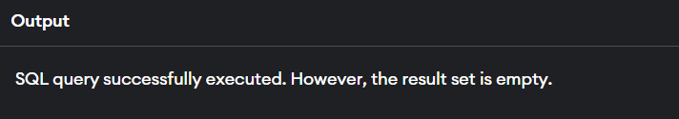

**INSERTING VALUES INTO TABLE:**

INSERT INTO Employees (name, department, salary, experience) VALUES

('Shamish', 'HR', 45000, 3),

('Om Naidu', 'IT', 60000, 5),

('Surya', 'HR', 50000, 4),

('Charan', 'IT', 62000, 6),

('Raghav', 'Finance', 48000, 2);

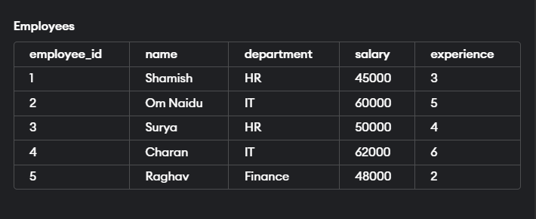

**SUM (TOTAL AMOUNT PAID TO EMPLOYEE AS SALARY):**

SELECT SUM(salary) AS total_salary FROM Employees;

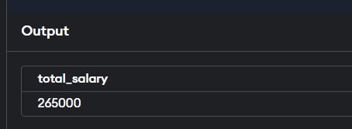

**COUNT+ GROUP_BY (NUMBER OF EMPLOYEES IN EACH DEPARTMENT):**

SELECT department, COUNT(*) AS employee_count

FROM Employees

GROUP BY department;

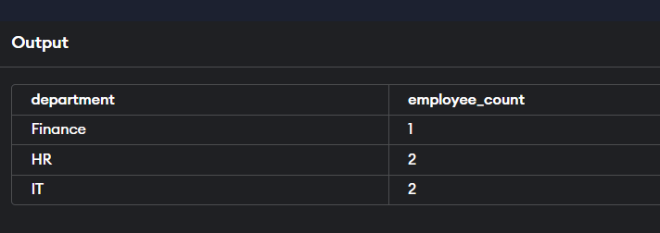

**AVG+ GROUP_BY (AVERAGE OF SALARY IN EACH DEPARTMENT):**

SELECT department, AVG(salary) AS average_salary

FROM Employees

GROUP BY department;

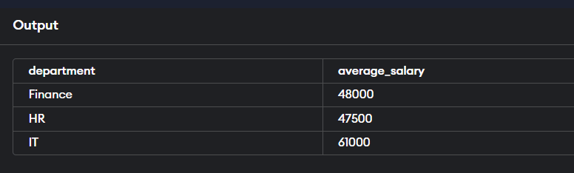

**MIN, MAX (MINIMUM AND MAXIMUM SALARY IN EACH DEPARTMENT):**

SELECT department, MAX(salary) AS max_salary, MIN(salary) AS min_salary

FROM Employees

GROUP BY department;

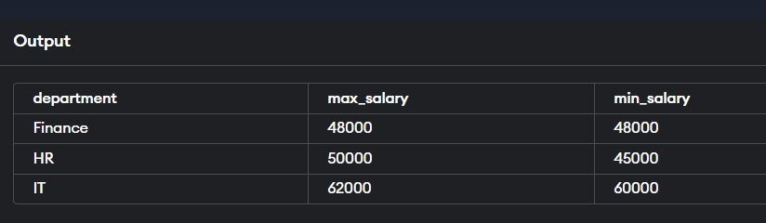

**SUM (TOTAL EXPERIENCE OF EMPLOYEE IN EACH DEPARTMENT):**

SELECT department, SUM(experience) AS total_experience

FROM Employees

GROUP BY department;

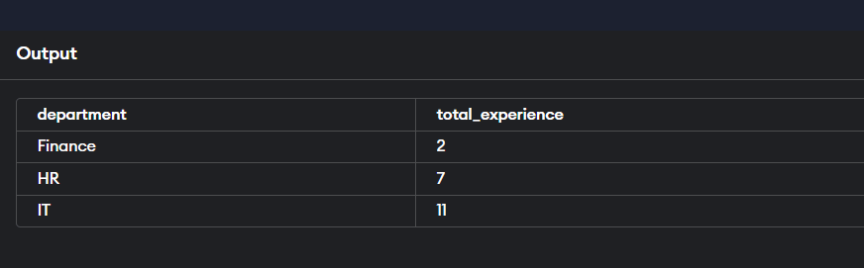

**GROUP_BY+ HAVING (EMPLOYEE MORE THAN ONE YEAR OF EXPERIENCE):**

SELECT department, COUNT(*) AS total_employees

FROM Employees

GROUP BY department

HAVING COUNT(*) > 1;

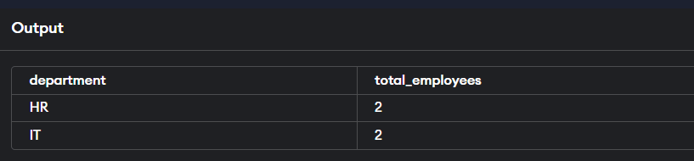

______________________________________________________________________________

NAME : Bodavula. Saivenkat

Email: [saivenkat.bodavula@gmail.com](mailto:saivenkat.bodavula@gmail.com)

Github: <https://github.com/saivenkat182004/ELEVATE-LABS-TASK-4>